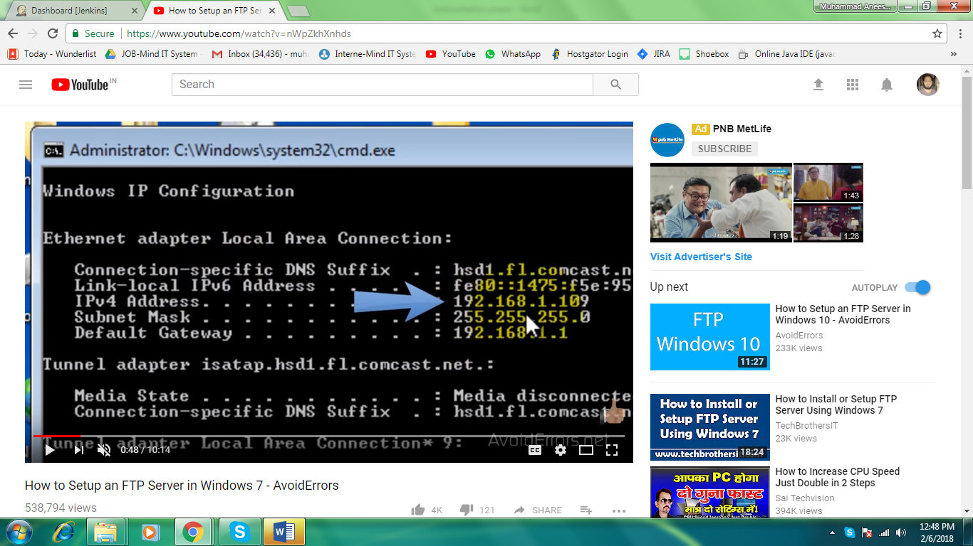

**Make a note of your machine ip address open it in your router.**

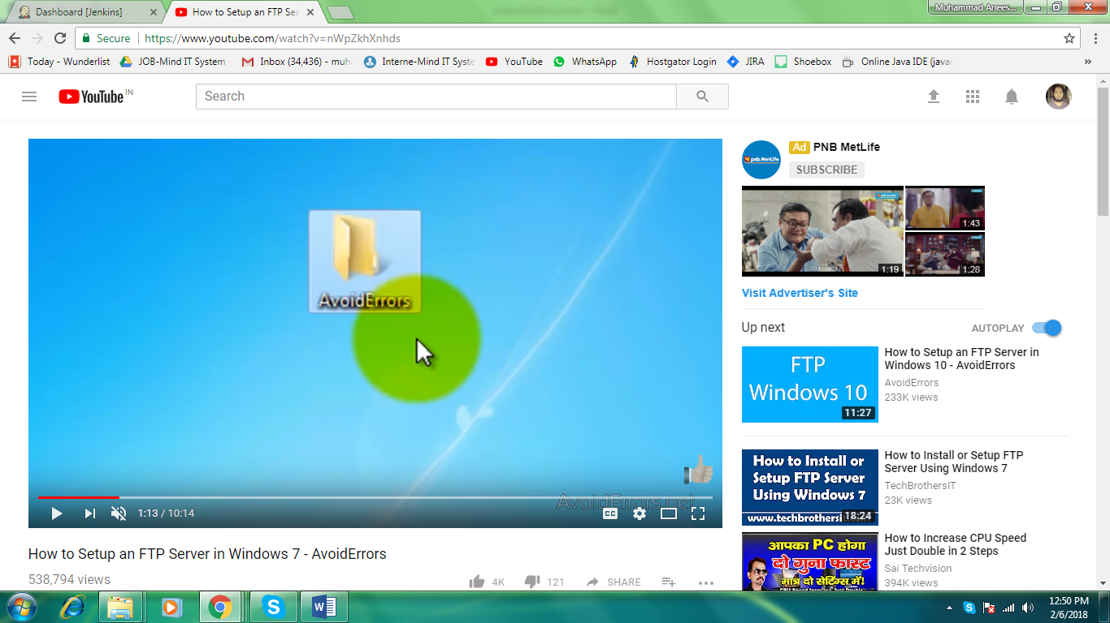

**Add one folder for ftp site in server and then connect it to iis in following steps**

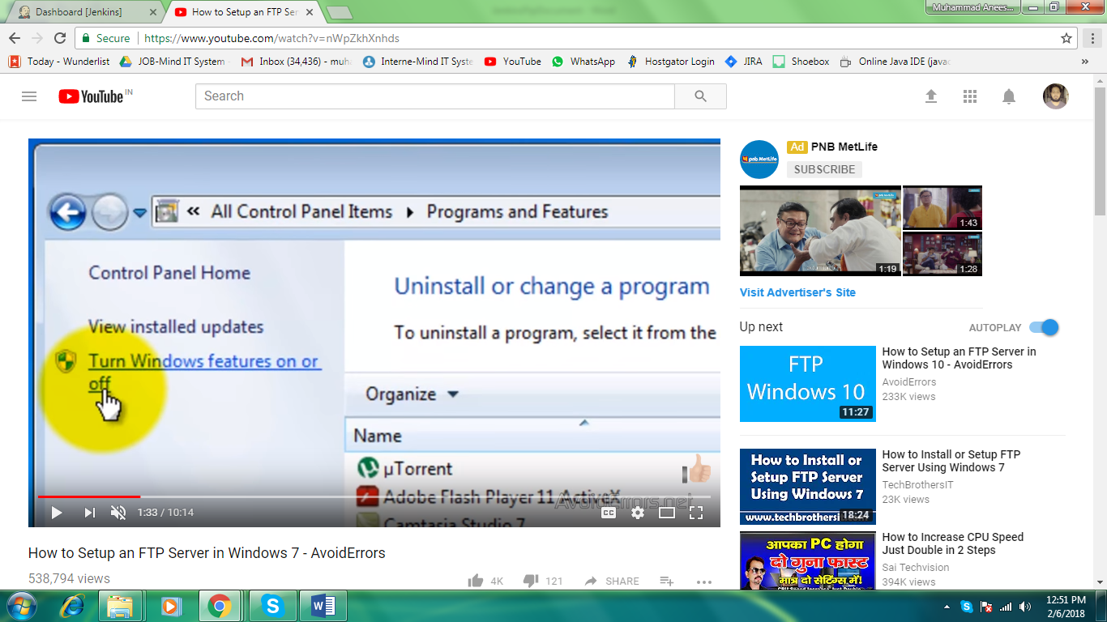

**Click on Turn windows feature on and off and on below services**

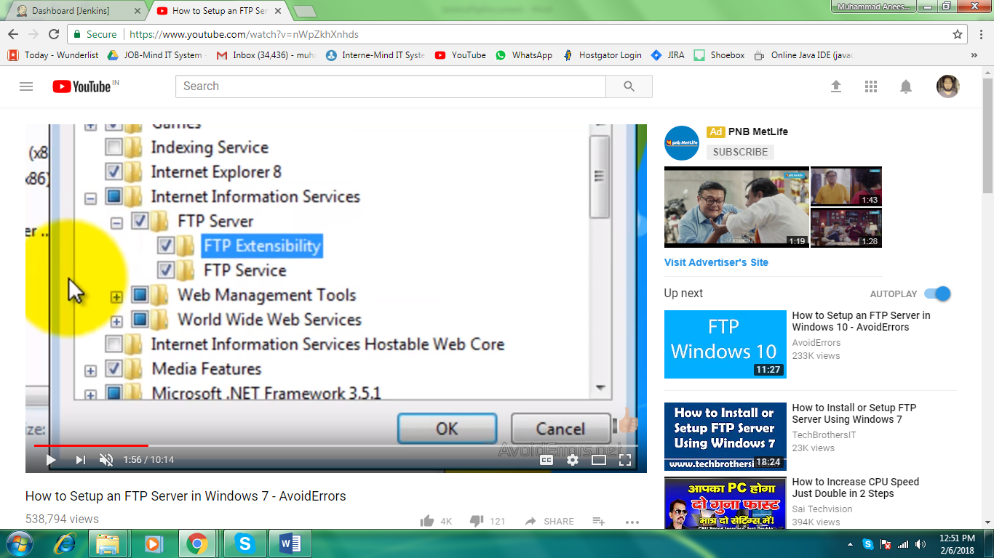

**Iis**

**ftp server**

**ftp extensibility**

**while doing above step on server 2008 r2 , need to add role services first then add ftp site and other option will display.**

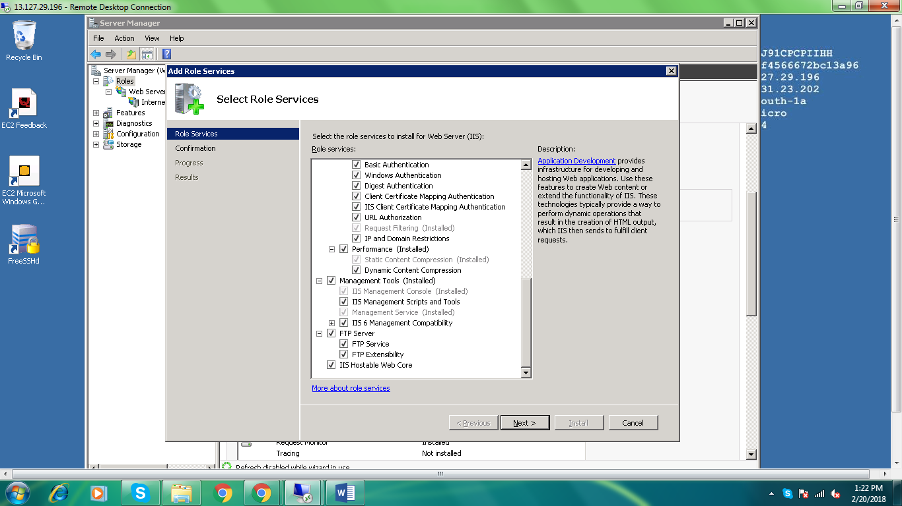

**ftp server**

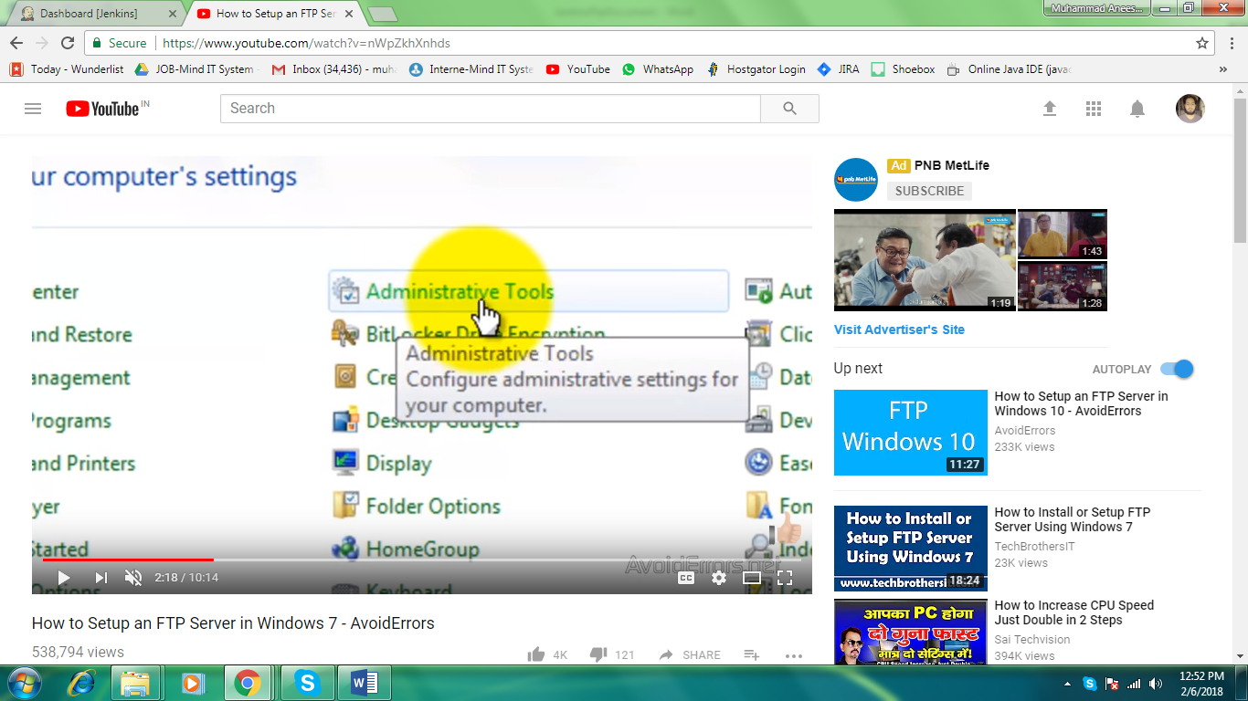

**Go to administrative tools and go to iis manager and configure ftp site there** 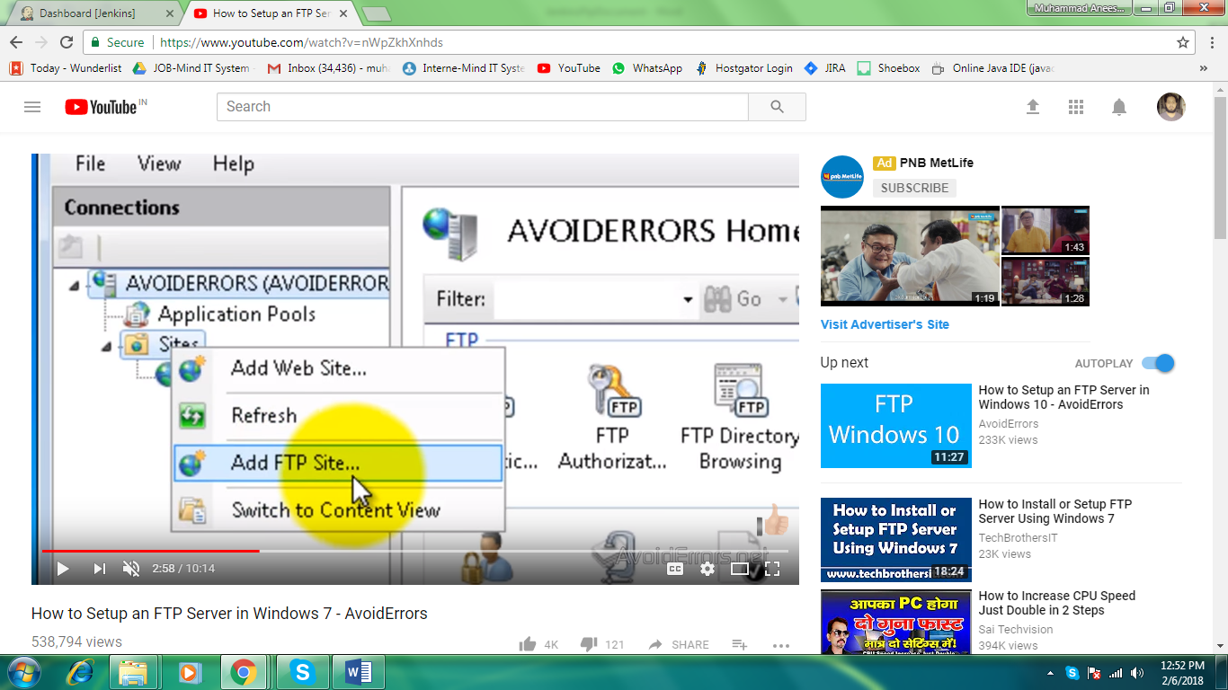

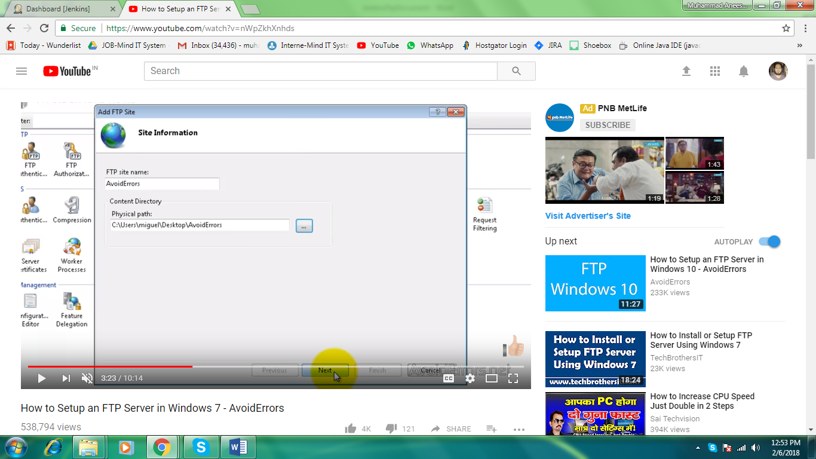**do the binding as All unassigned**

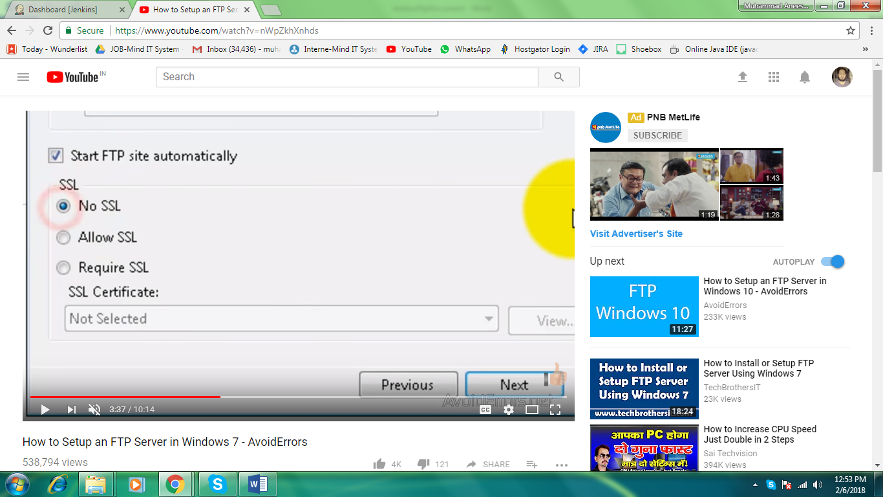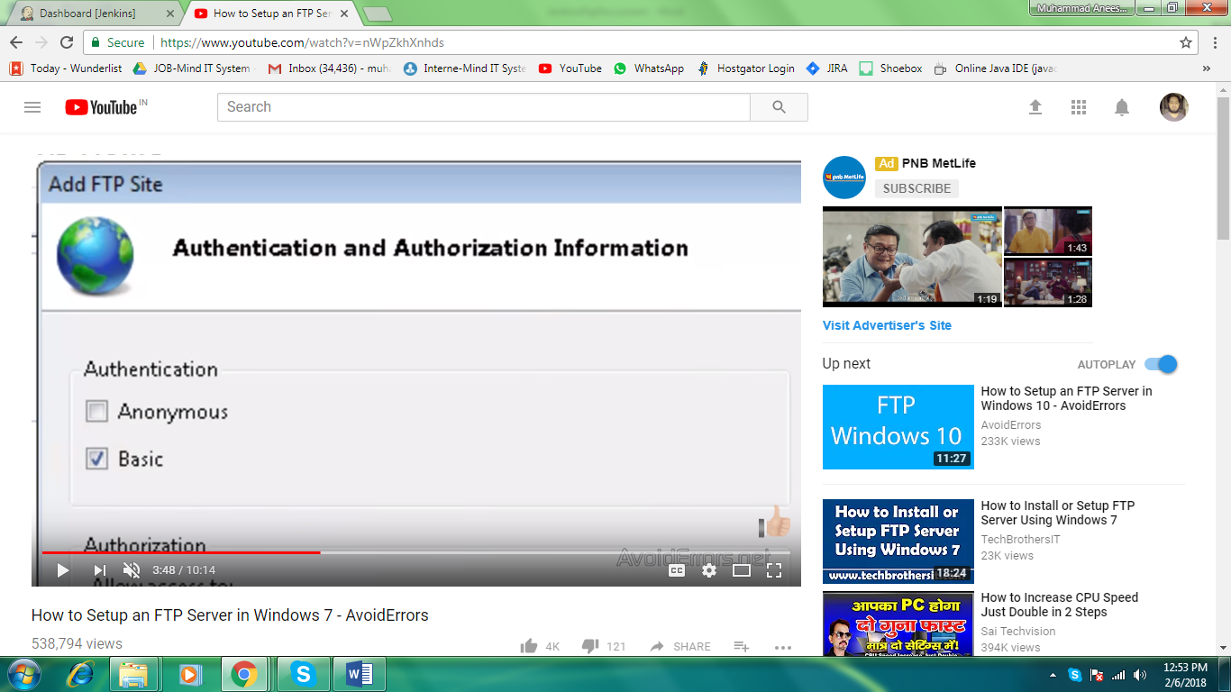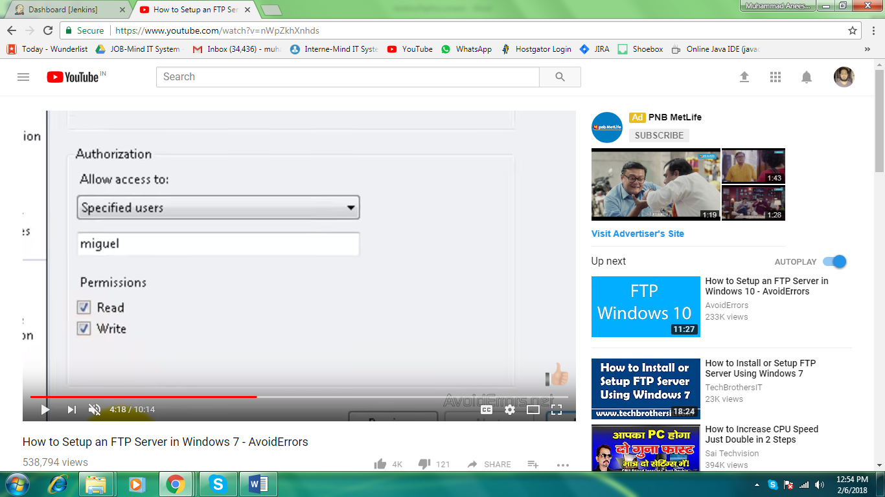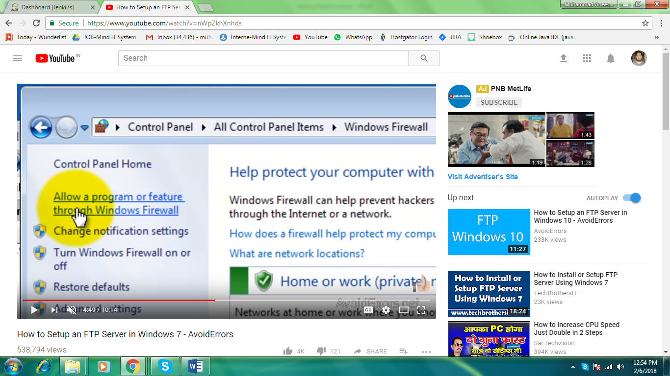

**Allow ftp server from window firewall**

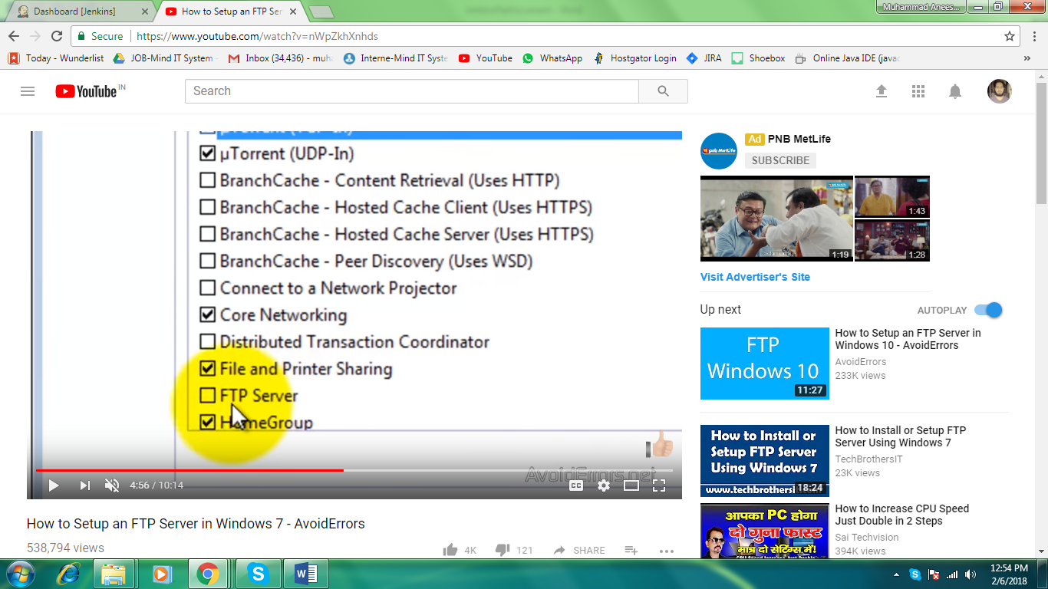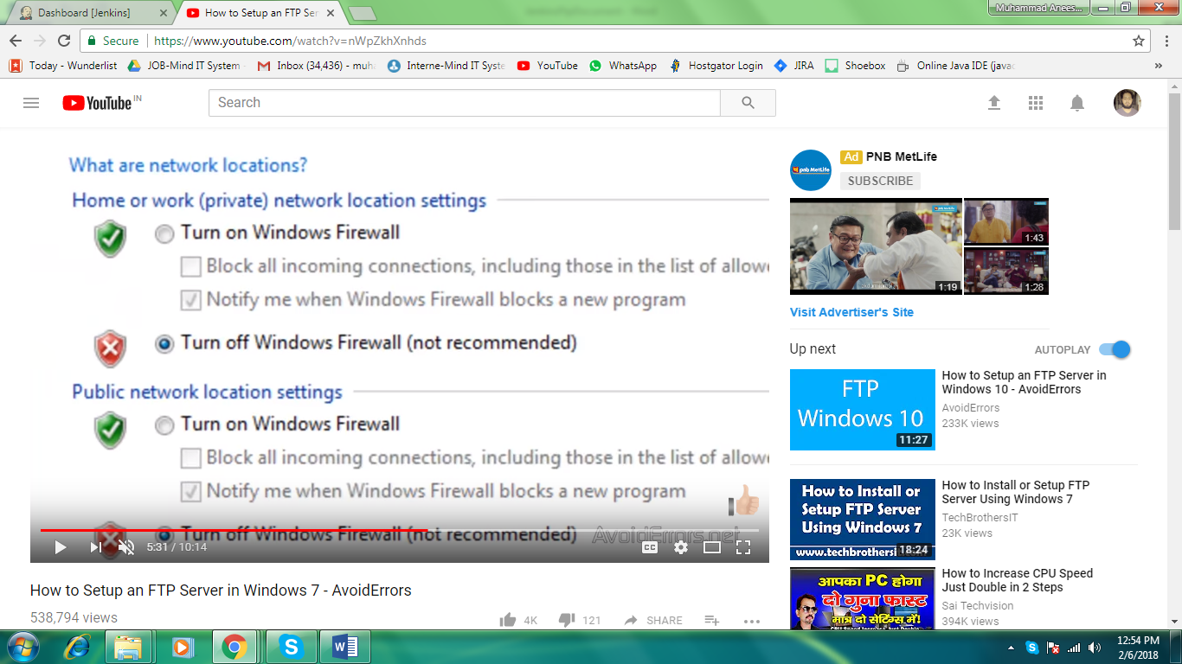**turn off windows firewall from sender machine.**

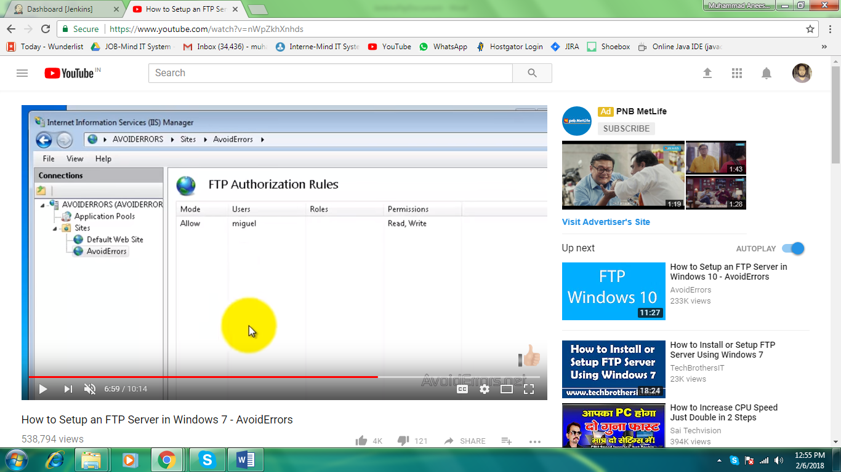**set the authorization rules as per your users in local machine**

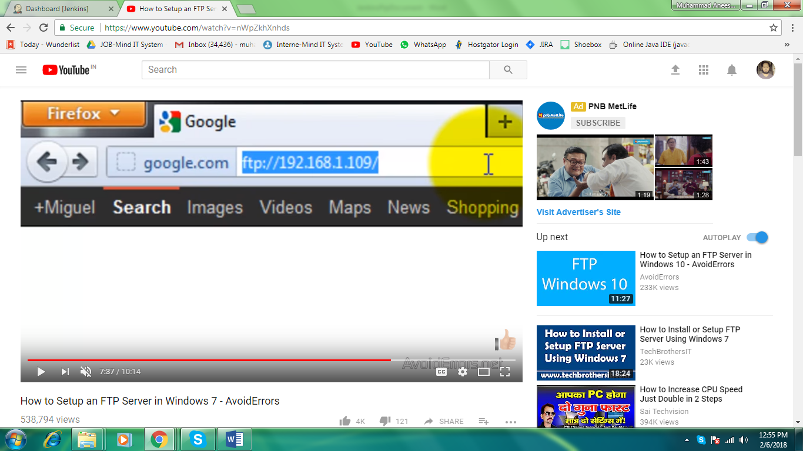**check it from like this**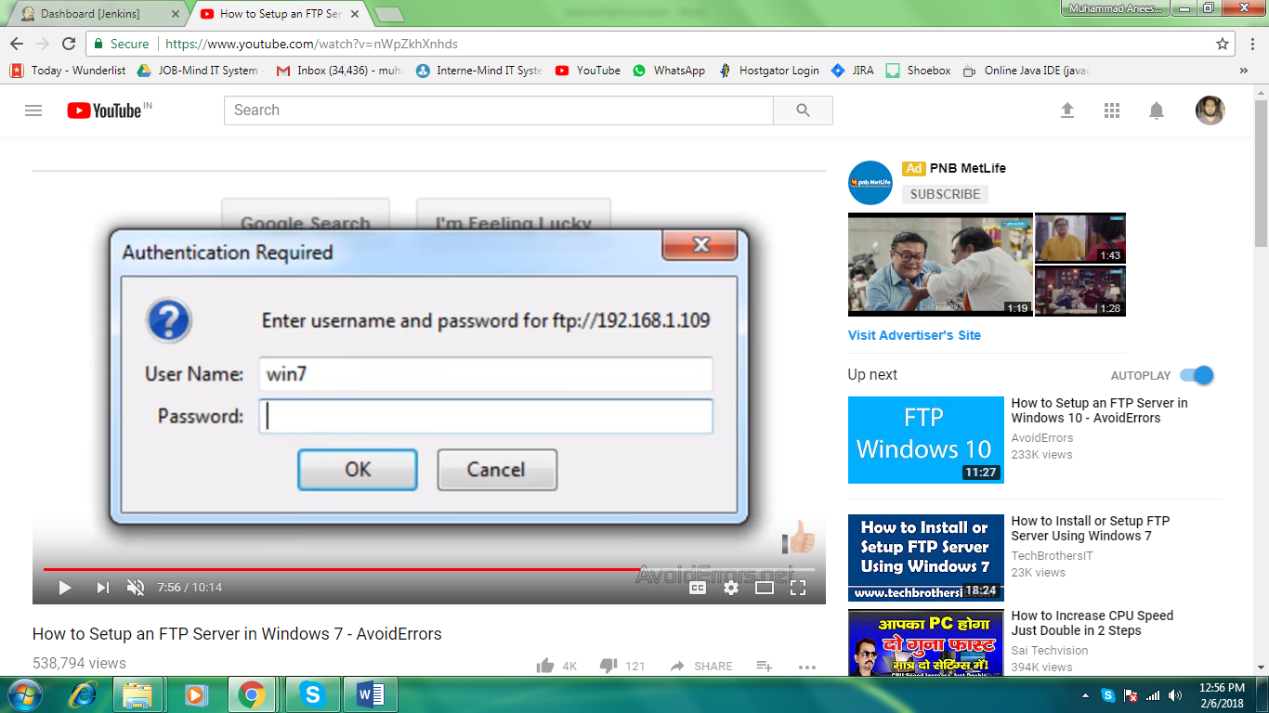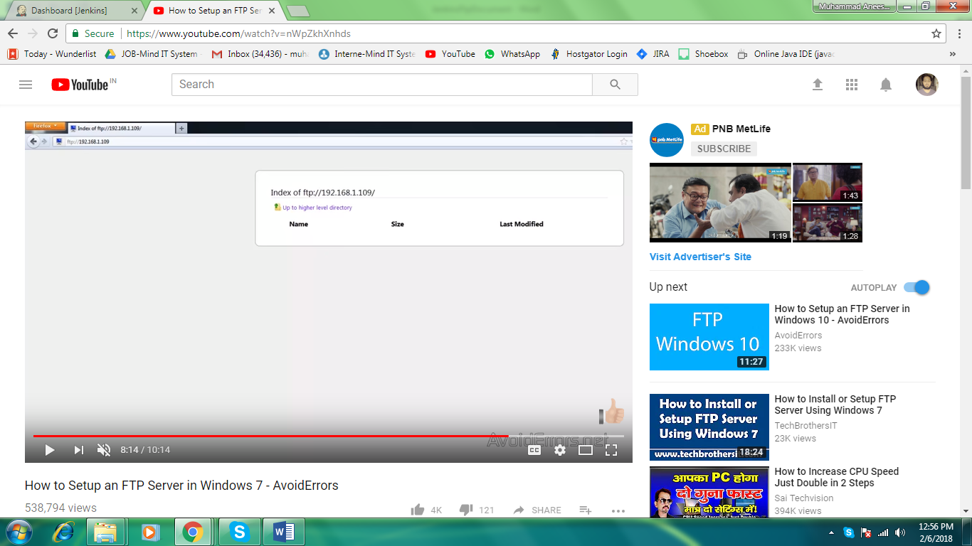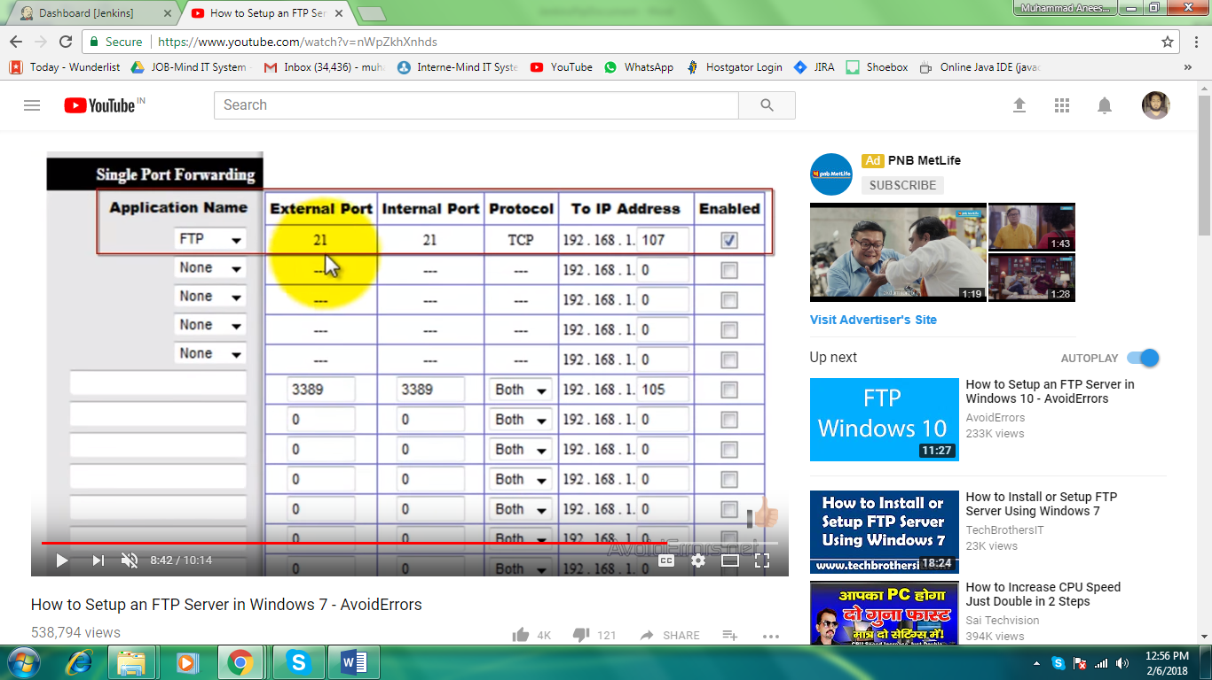

**This setting may be different for different router check as per your router model number on internent.**

**Finallly for same above you can check below video**

[**https://www.youtube.com/watch?v=nWpZkhXnhds**](https://www.youtube.com/watch?v=nWpZkhXnhds)

if after that transfers not starting in filezilla or through ftp , and error message is access is denied. Then check the permission and give the permission for users after checking names in security in properties of that folder.